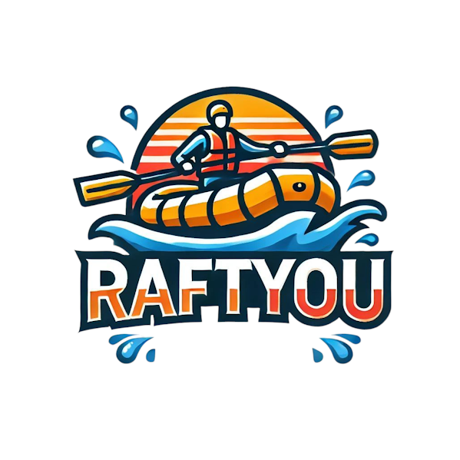

* + primary-color : Orange (Wheel) #F77F00
  + secondary-color: Prussian blue #003049
  + accent1-color: Fire engine red #D62828
  + accent2-color: Xanthous #FCBF49
  + heading-font: Frijole ( Regular 400 )
  + text-font: Barlow Semi Condensed ( Extra light 200, regular 400 )

Coolors URL:

https://coolors.co/003049-d62828-f77f00-fcbf49